Wilker Martins -58535

Use case : trade goods with other civilizations or AI players

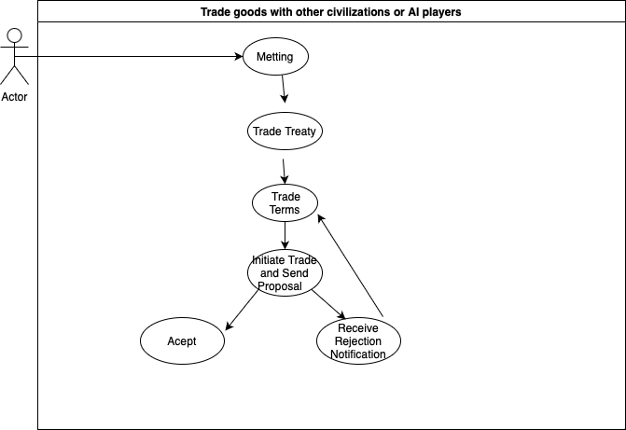

Primary Actor: Player

Summary: This use case describes the process of trading goods between the player and other civilizations or AI-controlled players in the FreeCol game.

Preconditions:

The player must have settlers or units that have established contact with other civilizations or AI players on the map.

Main Flow:

The player selects a colony or unit that has established contact with another civilization or AI player. The player opens the trade window. The player views two sections in the trade window: their inventory and the other party's inventory. The player selects the goods they want to offer in the "Offer" section and the goods they want to request in the "Request" section. Goods have assigned values. The player adjusts the quantities and types of goods offered and requested to reach an agreement on the total trade value. The player initiates the trade and sends the proposed terms to the other party. The other party receives the trade proposal and has the option to accept it, reject it, or make a counteroffer. If the other party accepts the proposal, the goods are exchanged, and the trade is successfully completed. If the other party rejects the proposal, the player can adjust the terms and try again.

Alternative Flow:

6a. The other party rejects the trade proposal.

The player receives a notification that the proposal was rejected. The player can adjust the trade terms and try again or abandon the trade.

Postconditions:

If the trade is successful, the exchanged goods are transferred between the player and the other party. The player can use the acquired goods in the trade to improve their colonies, expand their territory, and achieve their goals in the game. This use case describes the process of trading goods with other civilizations or AI players in FreeCol, highlighting the steps and possible alternative scenarios that may occur during the trade.